Green Infrastructure on School Grounds
Installing aesthetically pleasing green infrastructure on school grounds can be used as a learning tool for students, staff, and visitors. Schools can have input on design, support installation, install signage about how the system works for public education, and allow students to support maintenance of the green infrastructure during classroom learning or as an opportunity to complete volunteer hours while being out in nature. In the 2008 study, Children living in areas with more street trees have lower prevalence of asthma, researchers found that a higher density of street trees were associated with lower asthma rates among children in New York City.
For more information on Green Streets, please read our recent reports on Planning for Green Streets, Funding Green Streets, and Green Streets Case Studies.
Green infrastructure describes a wide range of stormwater management strategies that enable stormwater and melting snow to soak into soils near where they fall or be captured for a beneficial re-use, such as irrigation or flushing toilets. Keeping runoff out of the storm sewer system improves water quality and minimizes localized flooding.
Rain gardens, or bioretention systems, are shallow depressions that capture, filter, and infiltrate stormwater runoff. Rain gardens serve as a functional system to capture stormwater runoff at the source while being aesthetically pleasing.
Rain barrels are placed under a gutter’s downspout and are used to collect rainwater from roofs. The stored water can then be used for watering gardens, washing vehicles, or other non-potable uses.
Installing green infrastructure in publicly accessible locations can add opportunities for community visibility around green infrastructure efforts that might already be happening in the neighborhood.

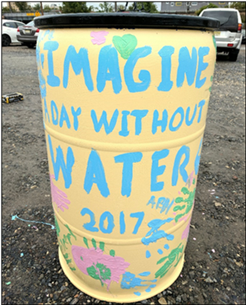
Rain barrel art at Brimm High School, 2017. Credit: Camden County Municipal Utility Authority.
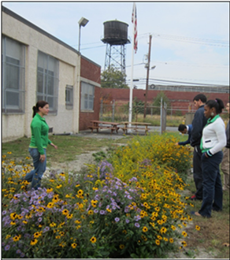
Demonstration Rain Garden
Education program with environmental science students at Brimm High School rain garden, October 2012. Credit: Rutgers.
Dr. Charles E. Brimm Medical Art High School in Camden, New Jersey installed a demonstration rain garden in May 2012 to intercept, treat, and infiltrate stormwater runoff from a portion of the school’s roof through a connected downspout. This rain garden is an outdoor classroom for staff, students, and visitors of the Brimm High School. Installation of this rain garden was a collaborative effort between the school, local volunteers, and Rutgers Cooperative Extension. The ongoing maintenance of this rain garden is completed by staff and students at the school.
In addition to installing green infrastructure, a native planting plan was used to educate students about the importance of native plants in the community.
This rain garden installation was supported through the Stormwater Management in Your Schoolyard educational program, which provides learning modules, activities, and community outreach for all ages of New Jersey students on the topics of water quality issues and stormwater management practices.
Green Infrastructure Champions Program
Green Infrastructure Champions are trained volunteers who are key players in implementing green infrastructure as a stormwater management approach town by town in New Jersey.

Learn more

Scan this QR code to learn more about the Green Infrastructure Champions.

Scan this QR code to learn more about green infrastructure through the New Jersey Green Infrastructure Municipal Toolkit.
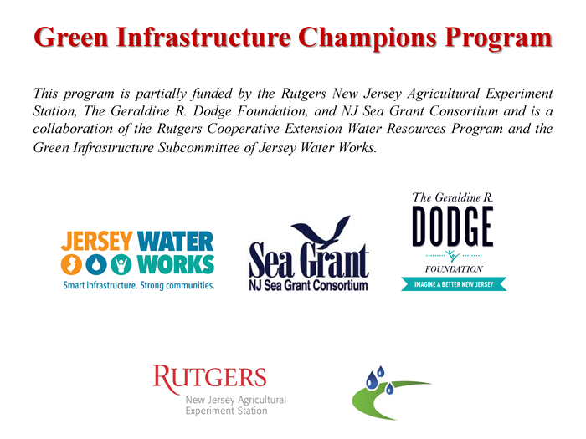
Space Reserved for Local Logos/Contact Information:

