Using Green Streets to Support Transportation Goals
Green streets are the effective use of multiple types of green infrastructure within the public right-of-way to capture and treat stormwater runoff from impervious surfaces while keeping streets accessible to all users. Green streets can help New Jersey communities become more resilient to intense storm events while preserving the primary function of streets: accommodating the movement of vehicles, pedestrians, bicyclists, and transit riders. Installing green infrastructure around roadways can produce traffic calming benefits, while views of natural space can reduce the stress response of all roadway users. A 2003 study summarized in Urban Trees and Traffic Safety: Considering U.S. Roadside Policy and Crash Data found that street landscape improvements such as curbside and median landscapes reduced accidents in Toronto, Canada by 5% to 20%.
For more information on Green Streets, please read our recent reports on Planning for Green Streets, Funding Green Streets, and Green Streets Case Studies.
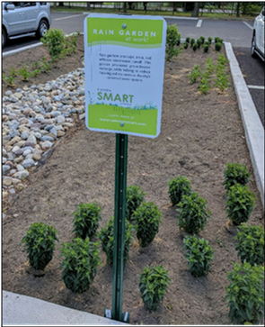
Benefits of Green Infrastructure for Green Streets
Green infrastructure describes a wide range of stormwater management strategies that enable stormwater and melting snow to soak into soils near where they fall or be captured for a beneficial re-use. Keeping runoff out of the storm sewer system improves water quality and minimizes localized flooding.
Pervious surfaces (also known as porous or permeable surfaces) allow water to percolate into the soil, filter out pollutants, and recharge the water table.
Pervious pavement systems are paved surfaces that allow stormwater to infiltrate into an underlying stone layer that stores it and allows it to seep slowly into the ground. With the installation of an underdrain system, these systems can be used in areas where infiltration is limited and will still filter pollutants and provide storage. Pervious pavement systems can be installed in parking lots, playgrounds, sidewalks, and more to help support community goals.

Rain garden at the Camden County Municipal Utilities Authority (CCMUA) administration building and sign to educate the public about rain gardens. Credit: CCMUA.
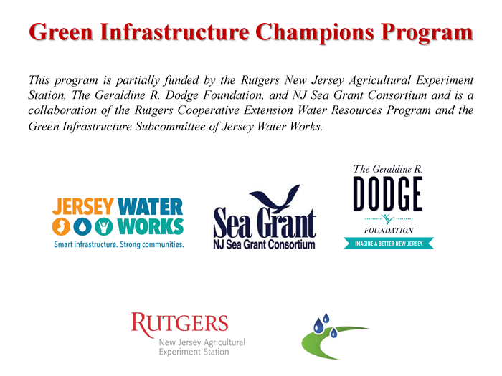
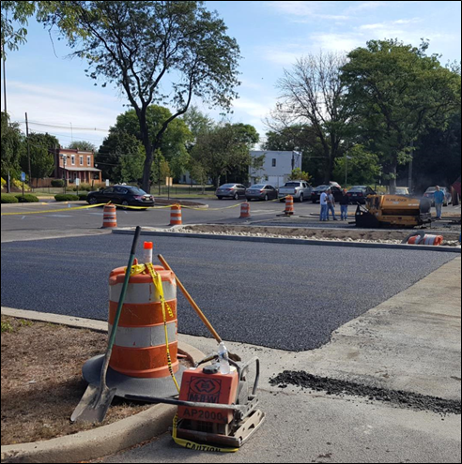
Green Infrastructure Champions Program
Green Infrastructure Champions are trained volunteers who are key players in implementing green infrastructure as a stormwater management approach town by town in New Jersey.

CCMUA Administration Building Pervious Pavement Installation
In May 2017, CCMUA completed the installation of pervious pavement and a rain garden at its administration building in Camden, New Jersey. CCMUA removed portions of the deteriorating parking lot and replaced it with porous asphalt, which helps to promote groundwater discharge. A rain garden was also installed in the deteriorating area of the parking lot to help intercept, treat, and filter stormwater runoff from the parking lot.
CCMUA is responsible for routine maintenance of the porous pavement and rain garden to ensure that the installed systems continue to work as designed. This includes garden upkeep, removing accumulated debris from the garden and porous pavement, and quarterly inspections to ensure proper functioning. Ensuring that the installed green infrastructure is maintained properly means that it continues to produce the expected water quality and environmental benefits.

Installing porous asphalt at the CCMUA Administration Building over an underlying stone layer to aid water infiltration. Credit: CCMUA.
Space Reserved for Local Logos/Contact Information:

Learn more

Scan this QR code to learn more about the Green Infrastructure Champions.

Scan this QR code to learn more about green infrastructure through the New Jersey Green Infrastructure Municipal Toolkit.

